<%@page contentType="text/html" pageEncoding="UTF-8" %>

<!DOCTYPE html>

<html>

<head>

<meta http-equiv="Content-Type" content="text/html charset=utf-8">

<title>LOGIN | SHOPPINGO</title>

<link rel="stylesheet" href="statics/css/menu.css" type="text/css">

<link rel="stylesheet" href="statics/css/basicStyle.css" type="text/css">

</head>

<body>

<nav>

<ul>

<li>

<a href="index.jsp"><b>Home</b></a>

</li>

<li>

<a href="register.jsp"><b>Registration</b></a>

</li>

<li>

<a href=""></a>

</li>

<li>

<a href=""></a>

</li>

</ul>

</nav>

<section>

<center>

<form method="post" action="loginServlet">

<table border="3" width="30%" cellpadding="3">

<thead>

<tr>

<th colspan="2">Login</th>

</tr>

</thead>

<tbody>

<tr>

<td>User Name</td>

<td><input type="text" name="uname" value="" placeholder="" /></td>

</tr>

<tr>

<td>Password</td>

<td><input type="password" name="pass" value="" placeholder="" /></td>

</tr>

<tr>

<td><input type="submit" value="Login" /></td>

<td><input type="reset" name="Reset" /></td>

</tr>

<tr>

<td colspan="2">Not Yet Registered..!!<a href="register.jsp">Register</a></td>

</tr>

</tbody>

</table>

</form>

</center>

</section>

</body>

</html>

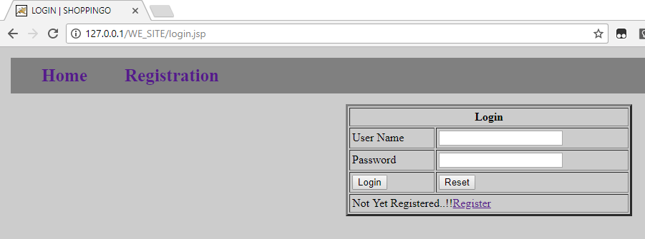

<%@page contentType="text/html" pageEncoding="UTF-8" %>

<!DOCTYPE html>

<html>

<head>

<meta http-equiv="Content-Type" content="text/html charset=utf-8">

<title>REGISTRATION | SHOPPINGO</title>

<link rel="stylesheet" href="statics/css/menu.css" type="text/css">

<link rel="stylesheet" href="statics/css/basicStyle.css" type="text/css">

</head>

<body>

<nav>

<ul>

<li>

<a href="index.jsp"><b>Home</b></a>

</li>

<li>

<a href="login.jsp"><b>Login</b></a>

</li>

<li>

<a href=""></a>

</li>

<li>

<a href=""></a>

</li>

</ul>

</nav>

<section>

<center>

<form method="post" action="registerServlet">

<table border="3" width="30%" cellpadding="3">

<thead>

<tr>

<th colspan="2">Registration Form</th>

</tr>

</thead>

<tbody>

<tr>

<td>User Name</td>

<td><input type="text" name="uname" value="" /></td>

</tr>

<tr>

<td>Email</td>

<td><input type="text" name="email" value="" /></td>

</tr>

<tr>

<td>Password</td>

<td><input type="password" name="pass" value="" /></td>

</tr>

<tr>

<td><input type="reset" value="Reset" /></td>

<td><input type="submit" value="Submit" /></td>

</tr>

<tr>

<td colspan="2">Already Registered.?<a href="login.jsp">Login</a></td>

</tr>

</tbody>

</table>

</form>

</center>

</section>

</body>

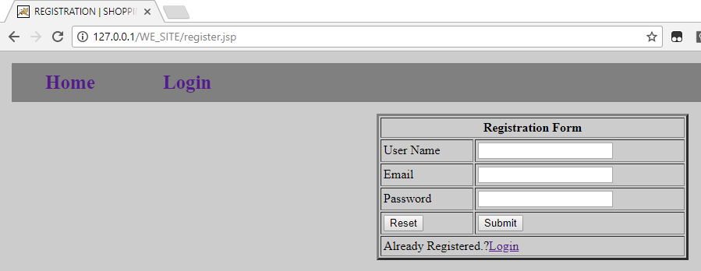</html>

package com.WE_SITE;

import java.io.IOException;

import java.io.PrintWriter;

import java.sql.Connection;

import java.sql.DriverManager;

import java.sql.PreparedStatement;

import java.sql.SQLException;

import javax.servlet.RequestDispatcher;

import javax.servlet.ServletException;

import javax.servlet.http.HttpServlet;

import javax.servlet.http.HttpServletRequest;

import javax.servlet.http.HttpServletResponse;

public class registerServlet extends HttpServlet {

protected void doPost(HttpServletRequest request, HttpServletResponse response) throws ServletException, IOException {

response.setContentType("text/html");

PrintWriter out = response.getWriter();

String nam = request.getParameter ("name");

String eml = request.getParameter ("email");

String pas = request.getParameter ("pass");

if(nam.isEmpty() || eml.isEmpty() || pas.isEmpty())

{

RequestDispatcher rd = request.getRequestDispatcher("register.jsp");

out.println("<font color=red>Please fill all the fields</font>");

rd.include(request, response);

} else {

varchar(100), addr varchar(100), age int, qual varchar(100), percent varchar(100), year varchar(100));

try {

Class.forName("com.mysql.jdbc.Driver");

Connection con = DriverManager.getConnection("jdbc:mysql://localhost/test?useSSL=false","root","root12345");

String query = "insert into user values(?,?,?)";

PreparedStatement ps = con.prepareStatement(query);

ps.setString(1, nam);

ps.setString(2, eml);

ps.setString(3, pas);

ps.executeUpdate(); // execute it on test database

System.out.println("Successfuly Registered");

ps.close();

con.close();

} catch (ClassNotFoundException | SQLException e) {

e.printStackTrace();

}

RequestDispatcher rd = request.getRequestDispatcher("home.jsp");

rd.forward(request, response);

}

}

}

package com.WE_SITE;

import java.io.IOException;

import java.sql.Connection;

import java.sql.DriverManager;

import java.sql.PreparedStatement;

import java.sql.ResultSet;

import java.sql.SQLException;

import javax.servlet.ServletException;

import javax.servlet.http.HttpServlet;

import javax.servlet.http.HttpServletRequest;

import javax.servlet.http.HttpServletResponse;

public class loginServlet extends HttpServlet

{

protected void doPost(HttpServletRequest request, HttpServletResponse response) throws ServletException, IOException

{

String un = request.getParameter("uname");

String pw = request.getParameter("pass");

try

{

Class.forName("com.mysql.jdbc.Driver");

Connection conn = DriverManager.getConnection("jdbc:mysql://localhost/test?useSSL=false","root","root12345");

PreparedStatement ps = conn.prepareStatement("select name, pass from user where name=? and pass=?");

ps.setString(1, un);

ps.setString(2, pw);

ResultSet rs = ps.executeQuery();

while (rs.next())

{

response.sendRedirect("home.jsp");

return;

}

response.sendRedirect("login.jsp");

return;

}

catch (ClassNotFoundException | SQLException e)

{

// TODO Auto-generated catch block

e.printStackTrace();

}

}

}